**Assignment : Socket Programming**

**Computer Networking**

**Tanmay Dureja (td1391)**

* Write an Echo Server/Client code using **socketserver** framework

**Echo Server:**

a) should receive a string from Client

b) If the string contains secret code “SECRET”, then server should return all the digits in

the string and count of digits

c) close the connection with client

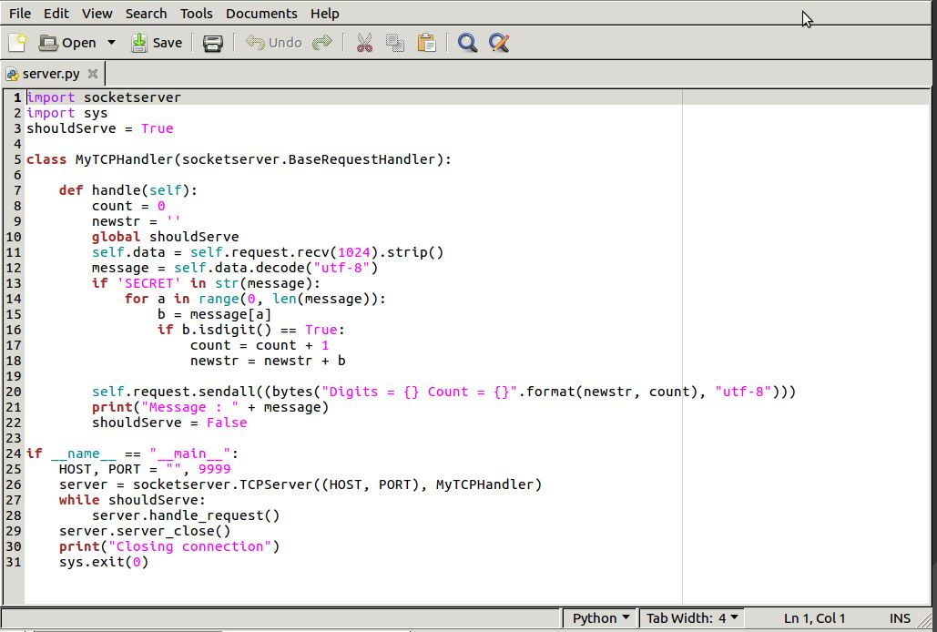

Capture 1 Server Program to count the number of digits if message contains the keyword ‘SECRET’

1. Open SocketServer, check for shouldServe flag to receive data and parse.
2. Line 8 and 9 in the program are used to initialize the values of variables ‘count’ and ‘newstr’ representing the counter and the newstring generated for the numbers respectively.
3. In Line 12 the message from the client is received by the server and decoded as string.
4. In Line 13 the keyword ‘SECRET’ is checked if in string received, if true the string is parsed character by character and compared if is a digit.

If the character is a digit, the counter is incremented, and the digit appended to newstring.

If the keyword ‘SECRET’ is not in the string received, an empty message with the default values for ‘count’ and ‘newstr’ are sent as the string is not parsed.

1. The newstring and counter data are sent over to the client.
2. Connection is closed.

**Echo Client:**

1. a) Should send a string to the server
2. b) Should receive the output

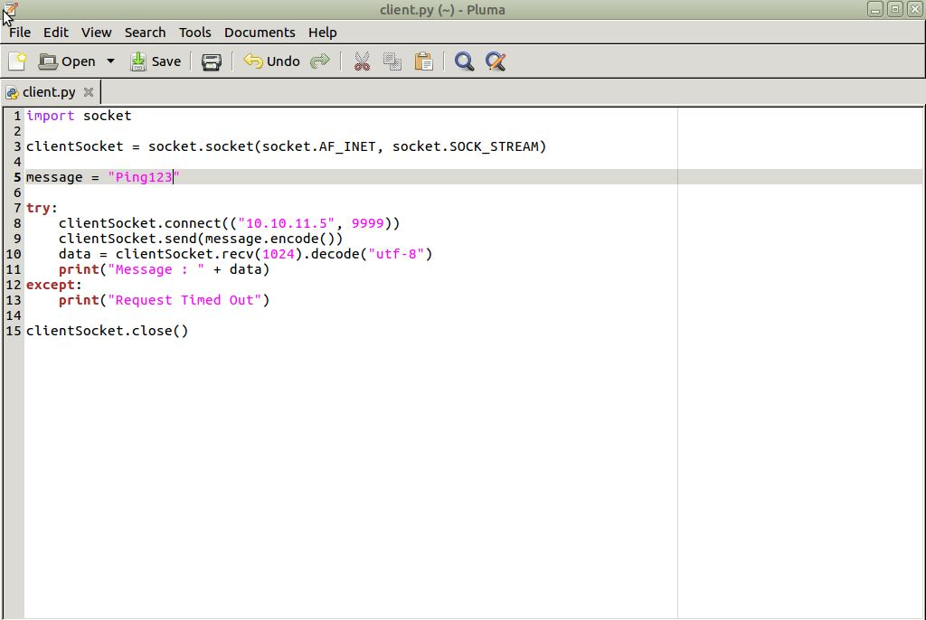

Capture 2 Client Program to send and receive data

1. Socket is created.
2. The message to be sent over to the server is defined in Line 5.
3. Now in Line 8-11 the client sends the message to the server and receives the parsed message and prints the data.
4. Socket is closed.

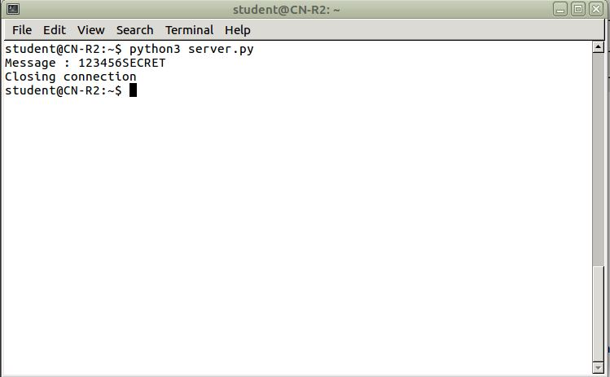

Capture 3 Server Program Example 1

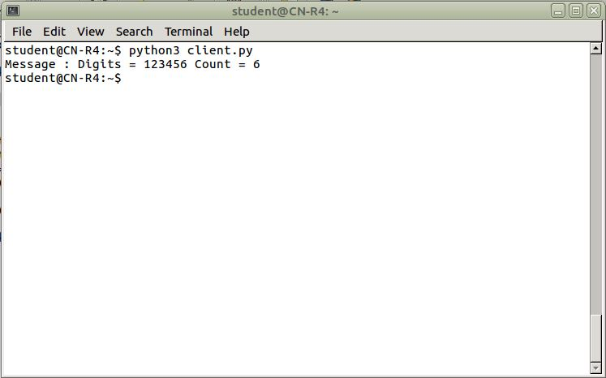

Capture 4 Client Program Example 1

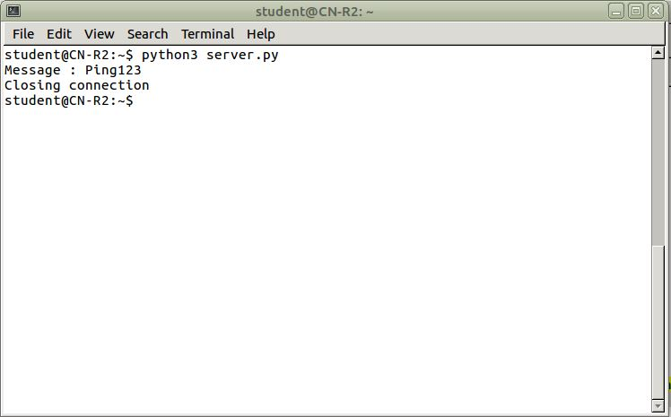

Capture 5 Server Program Example 2

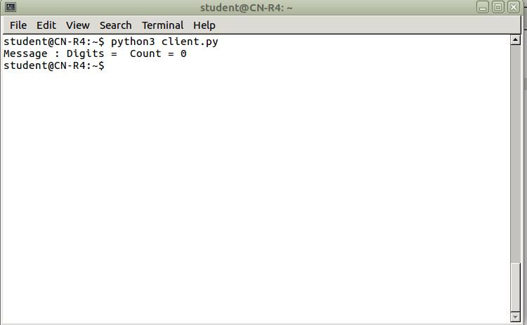

Capture 6 Client Program Example 2

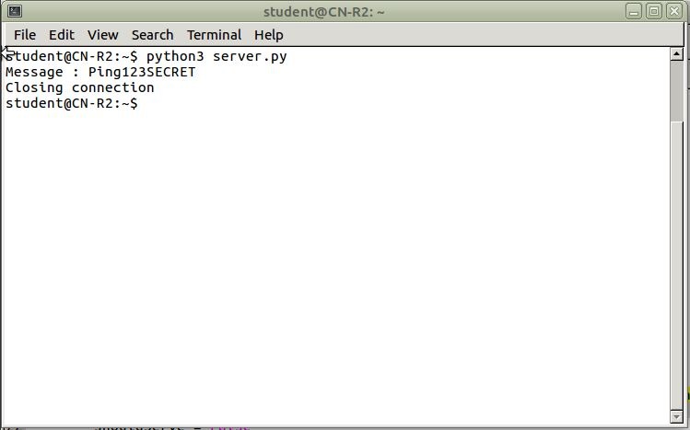

Capture 7 Server Program Example 3

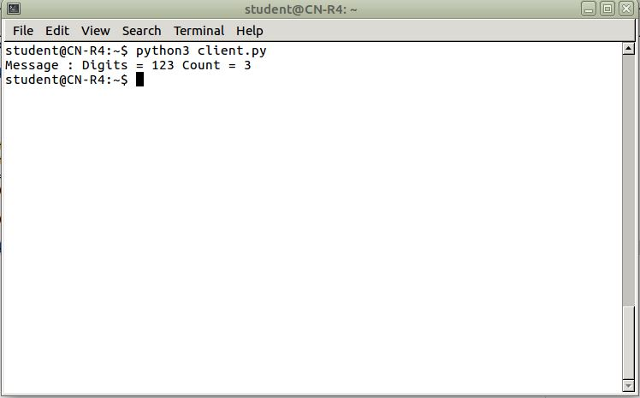

Capture 8 Client Program Example 3

* File Transfer over network using sockets.

**Server:**

a) should receive data from Client (create a text file)

b) write the received data in a file

c) close the connection

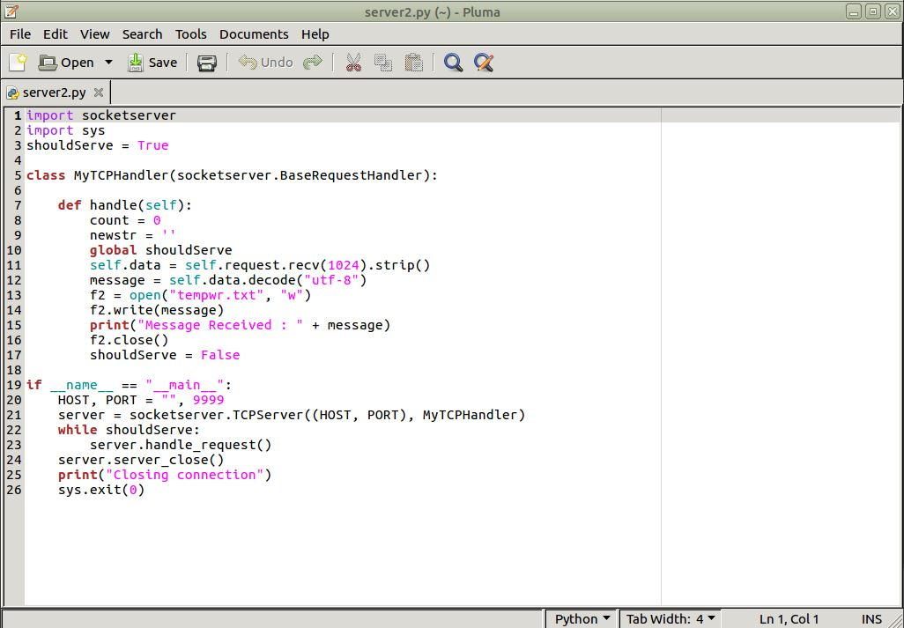

Capture 9 Server Program to write data to file

1. Create socketserver and check for flag if true.
2. In Line 11-12, the server receives the data and decodes it.
3. The server then opens the file, if not created then a new file is created and writes the received data on it.
4. The data received is also logged for the user.
5. The connection is then closed.

**Client:**

1. a) Connect with the server
2. b) Send the file
3. c) close the connection

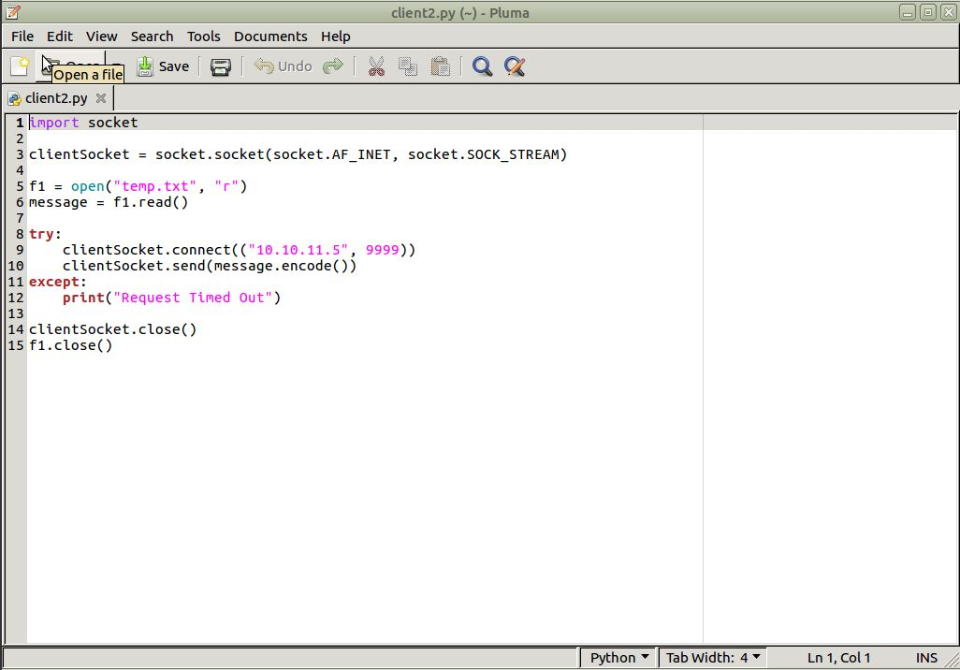

Capture 10 Client Program to read data from file and send to the server

1. Socket created.
2. In Line 5-6, the client opens and reads a file.
3. The client then sends the read data over to the server where the server stores the data in a file.
4. Socket closed.

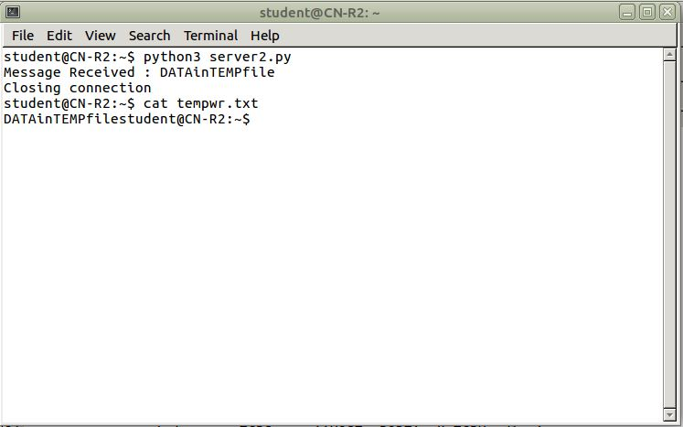

Capture 11 Server Program Example

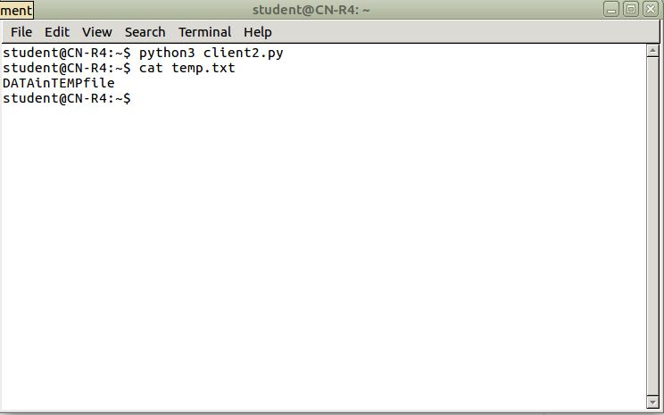

Capture 12 Client Program Example